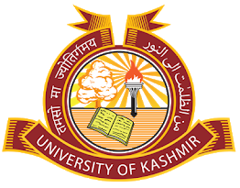 | DEPARTMENT OF PHARMACEUTICAL SCIENCES  School of Applied Sciences & Technology  University of Kashmir  NAAC Accredited Grade ‘A^{+’}  Hazratbal, Srinagar-190006(J&K), India

Notice
The Walk-In-Interview for the appointment of Junior Research fellow (JRF) for the research project "Semi-synthetic modification for hit to lead optimization of Marrubiin isolated from Marrubium vulgare depicting anti-inflammatory activity" sanctioned by ICMR, was scheduled to take place on March 25th, 2023 at 11:30 am in the office chamber of the Head, Department of Pharmaceutical Sciences, University of Kashmir has been postponed. A new date for the interview will be communicated in due course.

-Sd-

Prof. Mubashir H. Masoodi (Principal Investigator)
(ICMR)
No.: F(DOPS-Proj-ICMR)KU/23/02
Dated: 24-03-2023

