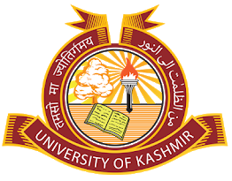 | DEPARTMENT OF PHARMACEUTICAL SCIENCES  School of Applied Sciences & Technology  University of Kashmir  NAAC Accredited Grade ‘A^{+’}  Hazratbal, Srinagar-190006(J&K), India
No.:_________________
Dated:______________
Notice
All the Ph. D Research Scholars who have applied for BSR Fellowship are hereby informed through this notice that their interview will be held on 12th October, 2021 at 11:30 am in the Gandhi Bhawan.

Sd/-
Prof (Dr.) Mubashir H. Masoodi
Head of the Department

